**Page1**: This is the home page of website containing linked webpages.

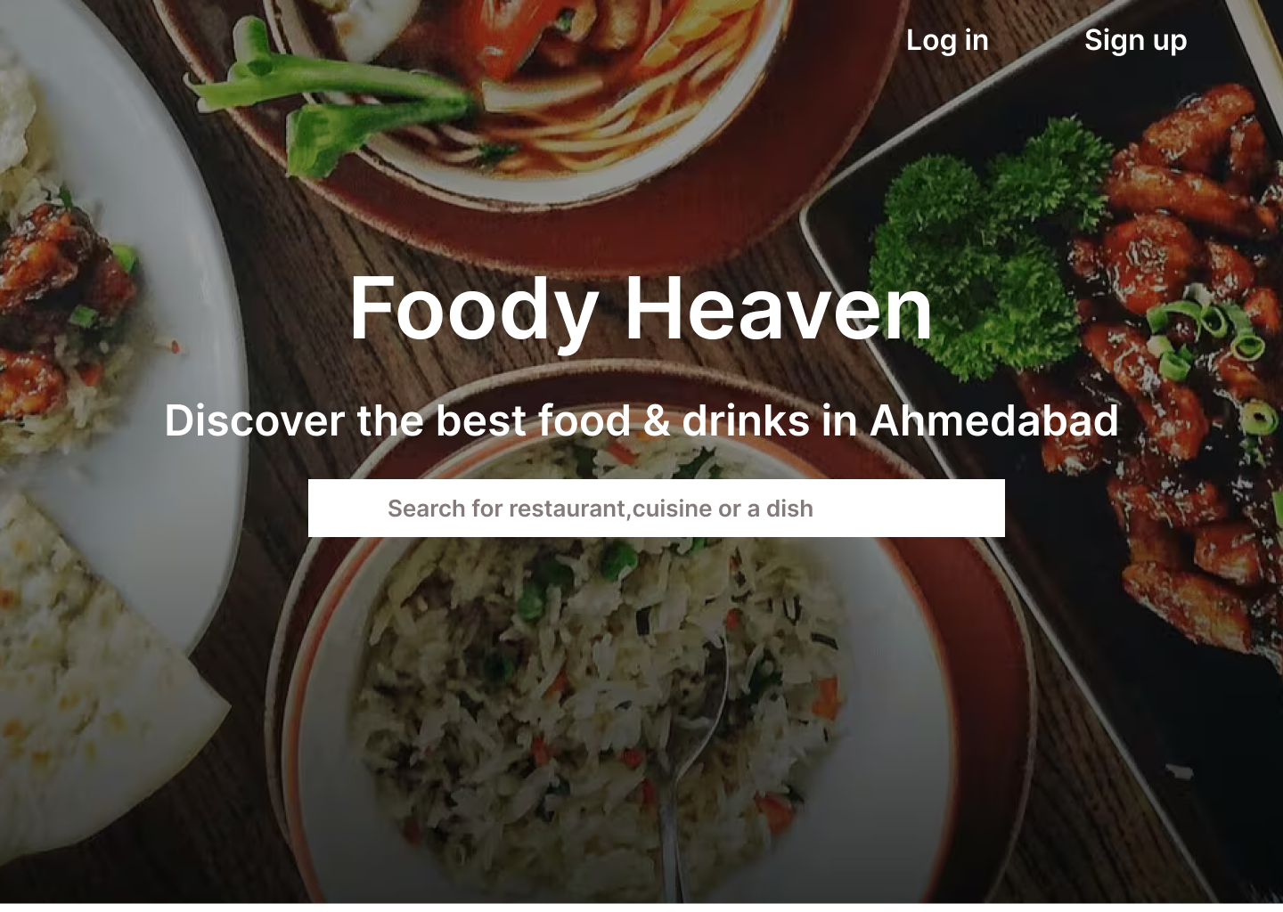

**Page 2**: Next page includes category of food to select

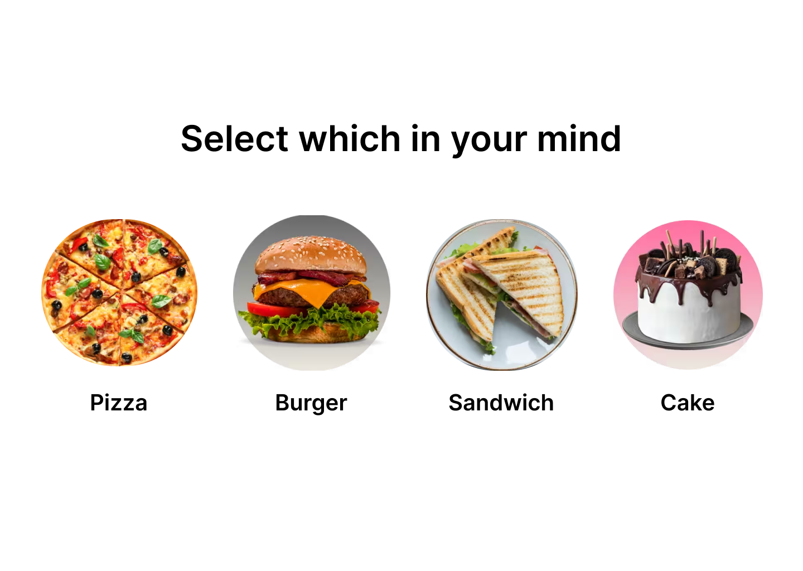

**Page 3:** Next page includes localities to select around ahmedabad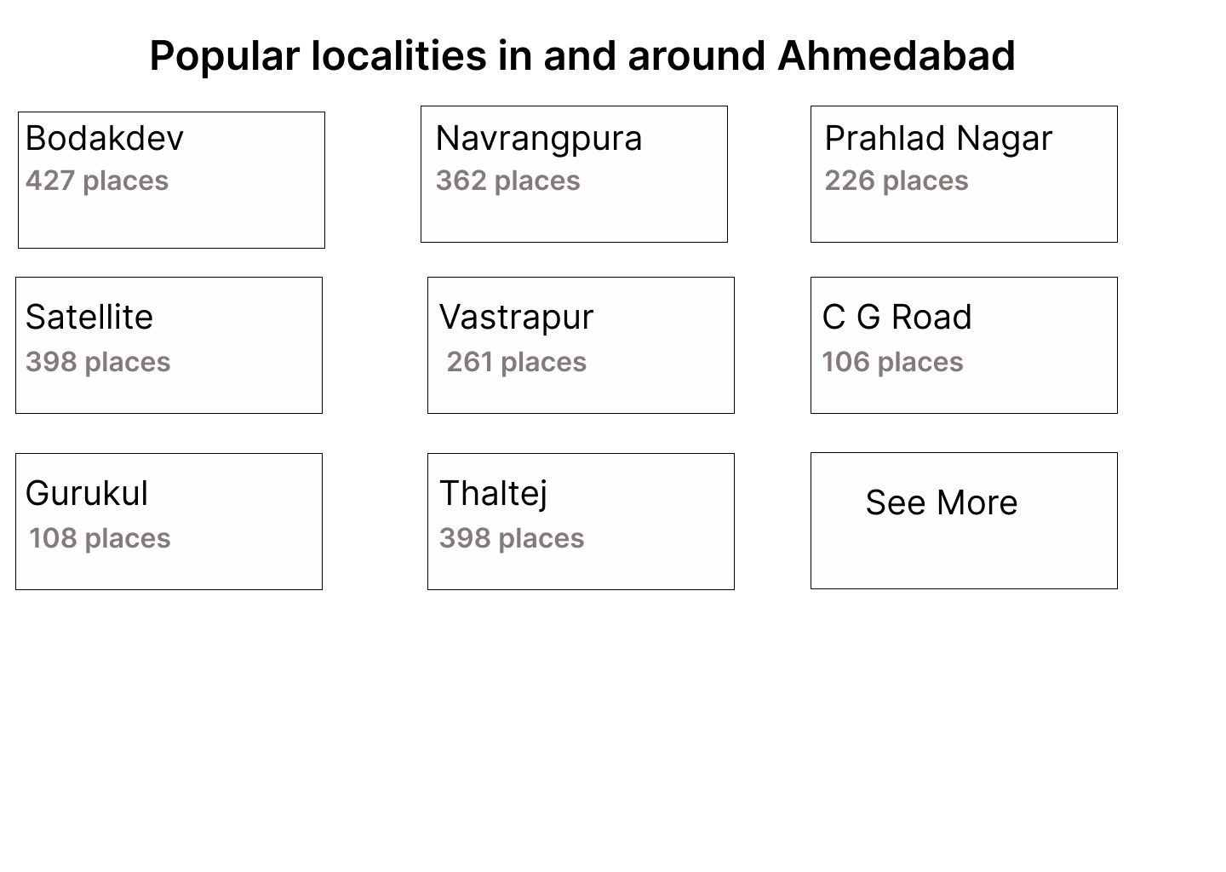

**Page 4**: Next page includes about information about Foody Heaven.

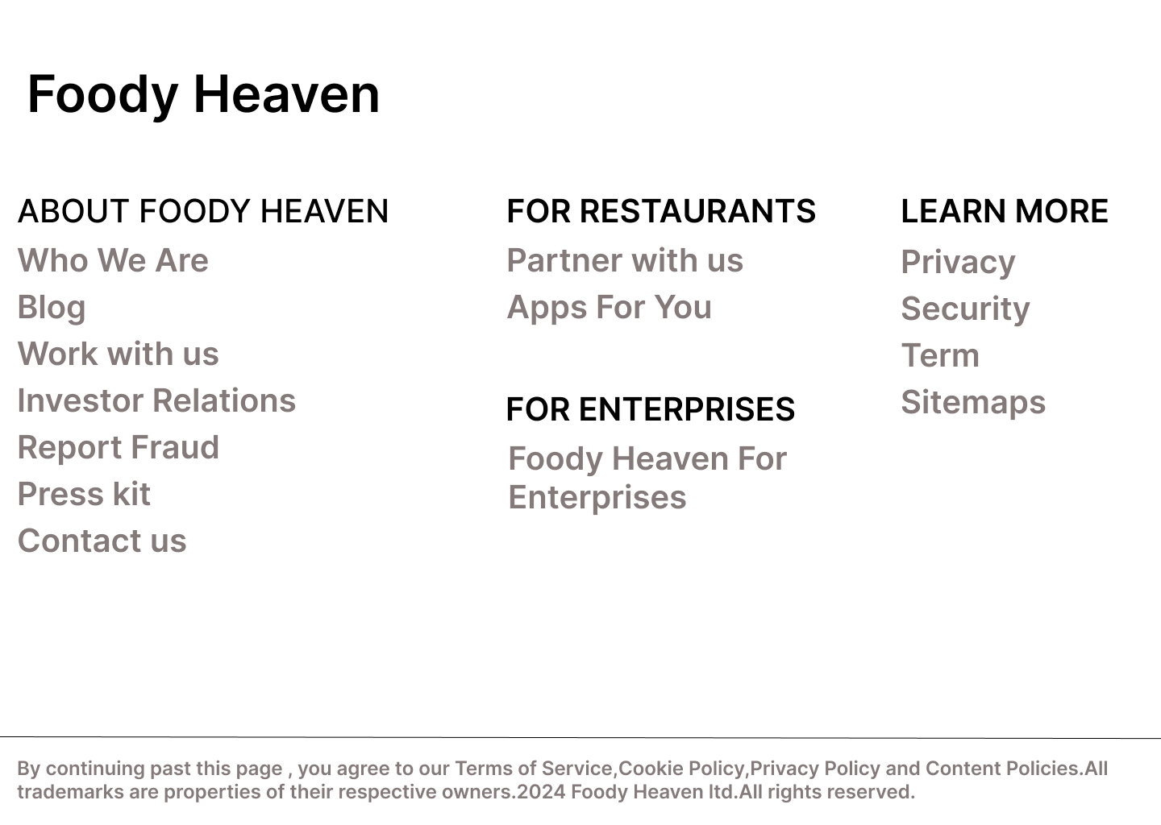

**Page 5**: Next page includes sign up page to create account.

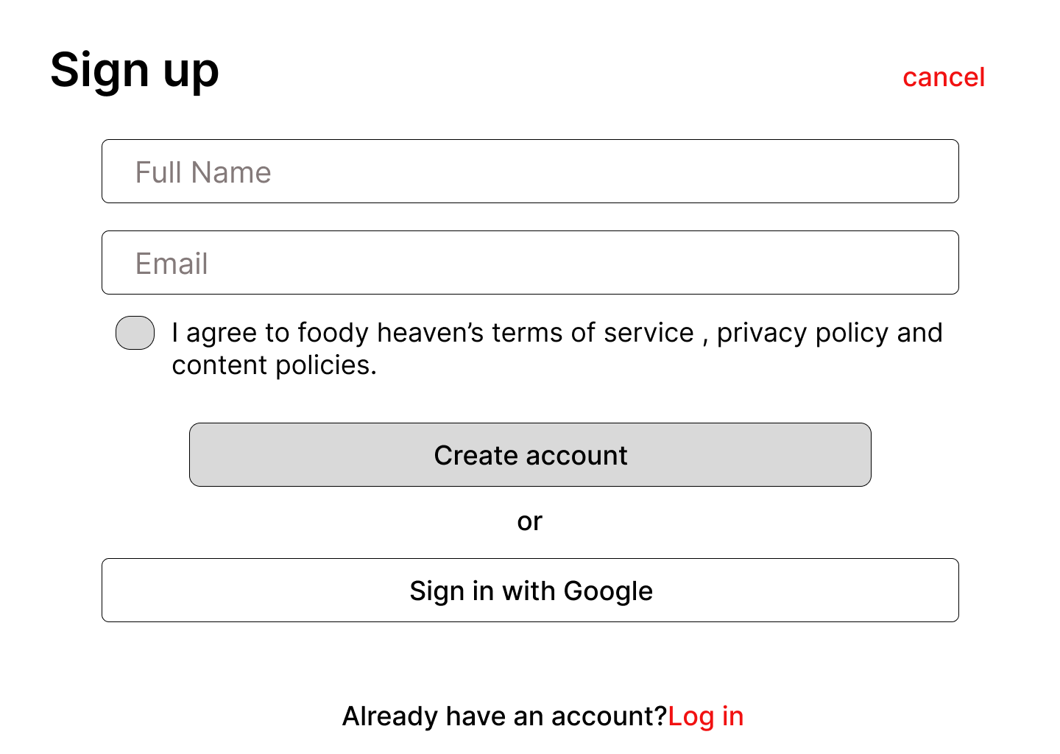

**Page 6**: next page is login page to log in to existing account.

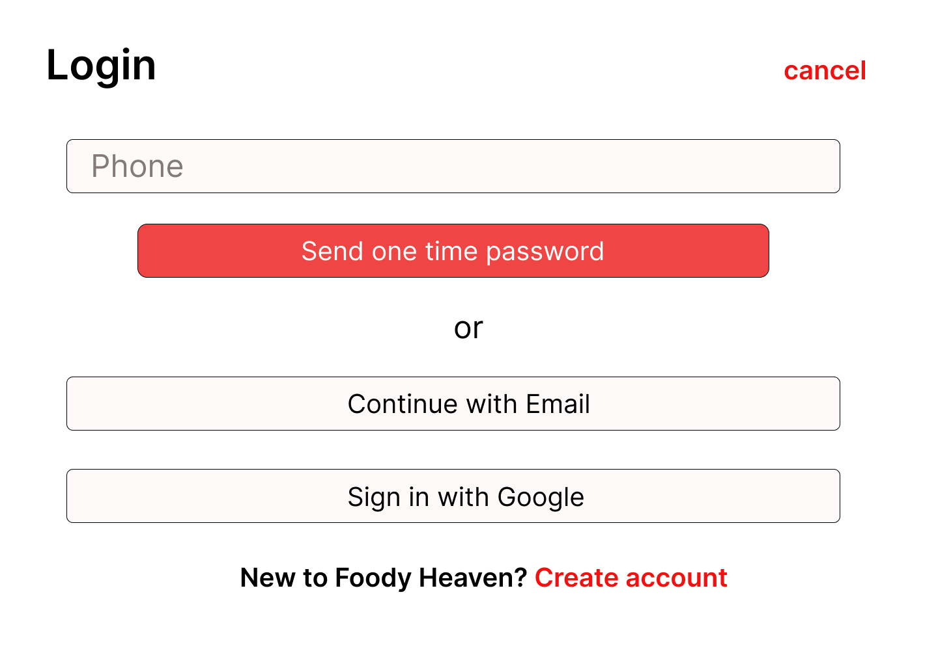

**Page 7**: next page includes options for pizza to category of pizza on homepage. 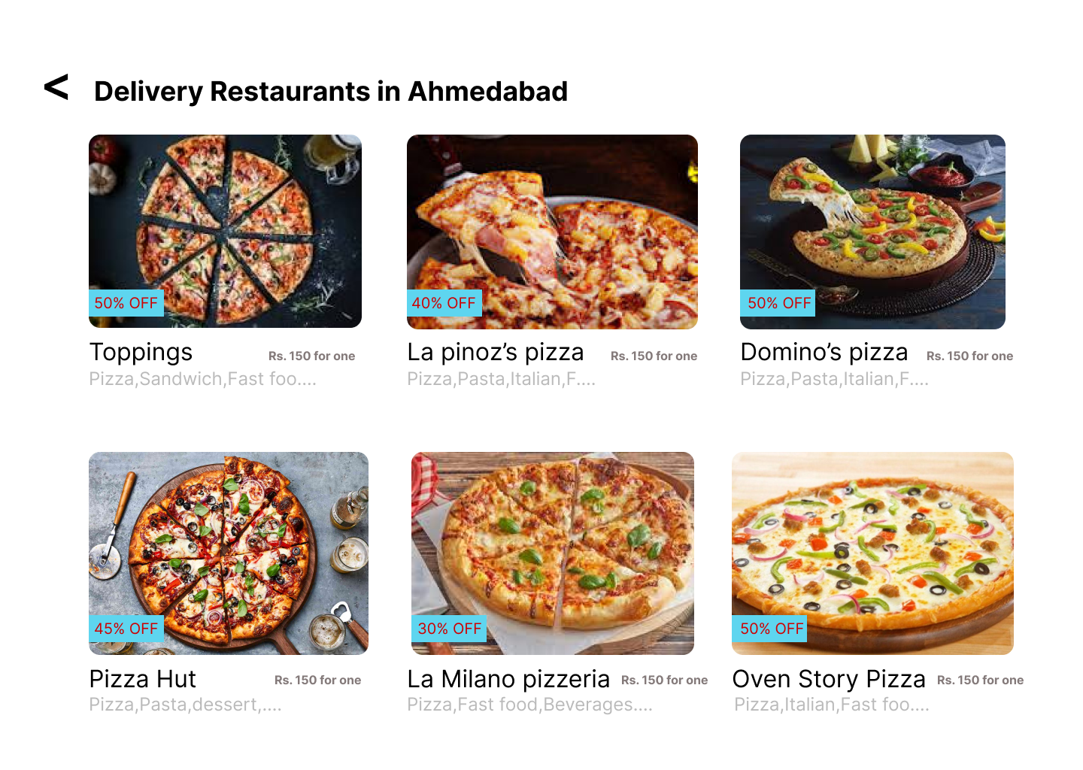

**Page 8**: Next page includes for cake to category of cake on home page.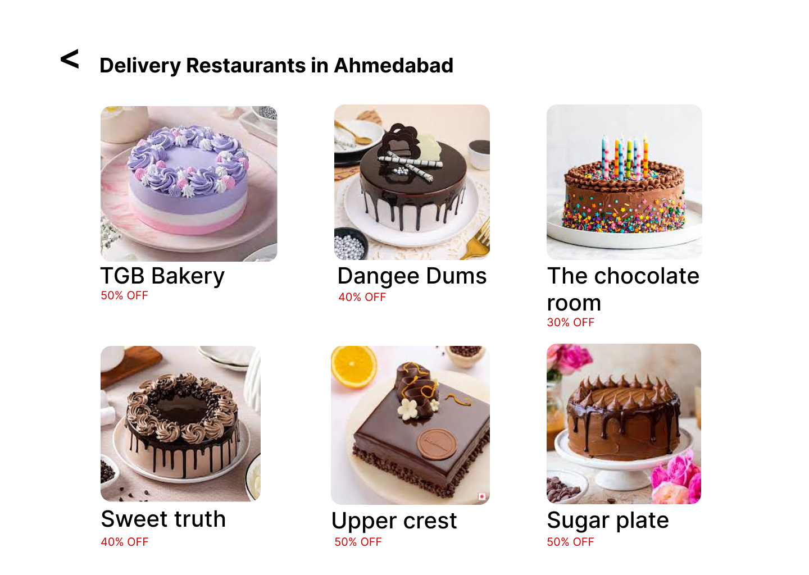

**Page 9:** Next page includes the cart page to cart option.